**Spring Cloud**

**Que: What is spring Cloud?**

**Ans**: Spring Cloud is an open-source framework for building distributed systems and microservices in the Java programming language. It provides tools and libraries for developers to quickly build and deploy microservices-based applications, addressing common challenges such as configuration management, service discovery, circuit breakers, distributed messaging, and more.

Spring Cloud is a collection of projects like load balancing, service discovery, circuit breakers, routing, micro-proxy, etc. will be given by Spring Cloud.

**Key components of Spring Cloud include:**

* Spring Cloud Config: Provides centralized externalized configuration management.
* Spring Cloud Netflix: Integrates with Netflix components like Eureka for service discovery, Ribbon for client-side load balancing, Hystrix for fault tolerance, and Zuul for API gateway.
* Spring Cloud Stream: Simplifies the development of event-driven microservices by providing abstractions for messaging middleware like RabbitMQ or Apache Kafka.
* Spring Cloud Sleuth: Provides distributed tracing capabilities to monitor and debug microservices architectures.
* Spring Cloud Security: Offers integration with OAuth2 and JWT for securing microservices.

**Que: What are the features of Spring Cloud?**

**Ans:** Spring Cloud provides a comprehensive set of features to simplify the development of distributed systems and microservices-based applications. Some key features include:

**1. Service Discovery**: Spring Cloud integrates with service discovery platforms like Netflix Eureka, Consul, and ZooKeeper, allowing services to register themselves and discover other services dynamically.

**2. Load Balancing:** With client-side load balancing using Ribbon or server-side load balancing with Spring Cloud Load Balancer, Spring Cloud ensures that requests are evenly distributed across service instances.

**3. Circuit Breaker:** Spring Cloud Circuit Breaker, often leveraging Netflix Hystrix, helps prevent cascading failures in a distributed system by providing fault tolerance and resilience to failures.

**4.** **Distributed Configuration:** Spring Cloud Config enables centralized externalized configuration management, allowing applications to retrieve their configurations from a remote server or a versioned repository.

**5. API Gateway:** Spring Cloud Gateway or Zuul provides an entry point for clients to access the microservices architecture. It handles routing, filtering, and load balancing of requests.

**6. Distributed Tracing:** Spring Cloud Sleuth provides distributed tracing capabilities, allowing developers to trace requests across multiple microservices and understand the flow of execution.

**7. Event-Driven Microservices:** Spring Cloud Stream simplifies the development of event-driven microservices by providing abstractions for messaging middleware like RabbitMQ or Apache Kafka.

**8. Security:** Spring Cloud Security integrates with OAuth2 and JWT for securing microservices, providing authentication and authorization mechanisms.

**9. Distributed Messaging:** Spring Cloud Bus facilitates communication between microservices by propagating configuration changes or events using messaging brokers.

**10. Monitoring and Management:** Spring Cloud provides tools and integrations for monitoring and managing microservices, including Spring Boot Actuator for application metrics and management endpoints.

**11. Distributed Tracing:** Spring Cloud Sleuth provides distributed tracing capabilities, allowing developers to trace requests across multiple microservices and understand the flow of execution.

**12. Container Orchestration:** Spring Cloud Kubernetes and Spring Cloud Kubernetes Config enable seamless integration with Kubernetes for deploying and managing containerized microservices.

**Que: What is Circuit Breaker?**

**Ans:**

* A circuit breaker is a design pattern used in distributed systems and microservices architectures to prevent **cascading failures** and improve fault tolerance.
* A **cascading failure** refers to a situation in a system where the failure of one component or part leads to the failure of other interconnected components or parts, causing a chain reaction of failures.
* A circuit breaker monitors the interactions between different components (such as microservices) within a system. When a component fails repeatedly or experiences an abnormal response time, the circuit breaker "trips" and stops sending requests to that component for a certain period.
* The main purpose of a circuit breaker is to prevent a single failing component from causing a cascade of failures throughout the system.

**For Example:**

Imagine you have multiple services (like different rooms in your house) communicating with each other in a larger system (your entire house). Each service handles specific tasks or functions, just like each room in your house serves a different purpose.

Now, if one of these services starts to behave unusually, then it may affect other services and stop them.

This is where the circuit breaker comes in. It acts as a guard between the services, monitoring their interactions. If one service starts to fail repeatedly or responds too slowly, the circuit breaker "trips," temporarily stopping any requests from going to that service.

**Que: What are the key features of Circuit Breaker?**

**Ans:** Key features of a circuit breaker include:

* **Monitoring:** The circuit breaker continuously monitors the health and responsiveness of the target component or service.
* **Thresholds:** It sets thresholds for error rates or response times. When these thresholds are exceeded, the circuit breaker trips.
* **State Management**: The circuit breaker maintains its own internal state, transitioning between states such as closed, open, and half-open based on the monitored conditions.
* **Fallback Mechanism:** In the event of a tripped circuit breaker, a fallback mechanism can be triggered to provide alternative behavior or responses to clients.
* **Automatic Recovery:** After a certain period of time, the circuit breaker may attempt to reset and transition back to a closed state to allow requests to resume.

**Que: What is Hystrix?**

**Ans:** Hystrix is a library developed by Netflix for implementing the circuit breaker pattern in distributed systems. It provides fault tolerance and resilience to latency and failure in complex distributed architectures, particularly in microservices-based applications.

* **Circuit Breaker:** Prevents cascading failures by stopping requests to a failing service.
* **Fallback Mechanism:** Executes alternative logic when a service call fails.
* **Timeouts and Latency Control:** Sets timeouts for service calls to prevent indefinite waiting.
* **Metrics and Monitoring:** Collects and exposes metrics for monitoring the health of services and circuit breakers.
* **Concurrency and Thread Pool Management**: Manages thread pools to prevent resource exhaustion in highly concurrent environments.

**Que: How to Implement Hystrix/ Circuit Breaker in Spring boot Project?**

**Ans:** You need to use Hystrix Library for Circuit Breaker.

1. Add Hystrix Dependency: Include the Hystrix dependency in your pom.xml .
2. Enable Hystrix: In your main Spring Boot application class, add the @**EnableHystrix** annotation to enable Hystrix functionality:
3. Create a Hystrix Command: Define a class that extends HystrixCommand and implement the logic for the service call within the run() method.
4. Invoke the Hystrix Command: Use the Hystrix command in your service layer or controller to make the protected service call.

**Que: What is Fallback?**

**Ans:** In the context of Hystrix or other circuit breaker implementations, the fallback mechanism provides an alternative response or behavior when a service call fails or takes too long to respond.

**Spring Cloud Eureka**

**Que: What is the meaning of Service registration and discovery?**

**Ans:** Service Registration: Microservices register themselves with a central service registry upon startup, providing details like their network location and service ID.

Service Discovery: Client applications dynamically locate and communicate with services by querying the service registry at runtime, rather than relying on hardcoded endpoints.

In summary, service registration involves microservices registering themselves with a central service registry upon startup, while service discovery enables client applications to dynamically locate and communicate with other services by querying the service registry at runtime. Together, service registration and discovery facilitate dynamic and flexible communication between microservices in distributed systems, promoting scalability, resilience, and agility.

In Spring Boot, service registration and discovery can be achieved using Spring Cloud Netflix components, primarily Eureka Server for service registration and discovery, and Eureka Client for service registration.

**Que: What is Spring Cloud Eureka?**

**Ans:** Spring Cloud Eureka is a component of the Spring Cloud framework that provides service registration and discovery capabilities for building distributed systems and microservices architectures. It is inspired by Netflix Eureka and is designed to simplify the development of cloud-native applications by enabling dynamic and resilient service discovery.

Spring Cloud Eureka helps in building distributed systems by providing a way for services (like microservices) to find and communicate with each other easily.

**For Example:** Imagine you have multiple services running in your system, each performing a different task, like handling user authentication, processing orders, or managing inventory. Spring Cloud Eureka acts like a phone directory for these services.

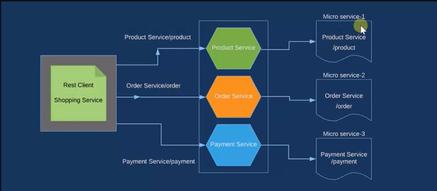

**Que: What are the key Features of Eureka?**

Ans: Spring Cloud Eureka and its key features:

* **Service Registration:** When a service starts up, it tells Eureka, "Hey, I'm here!" by registering itself with Eureka when they start up. It provides information like its name, network address, host, port, health status, and other attributes.
* **Service Discovery:** If another service needs to communicate with the first one, it asks Eureka, "Hey, where can I find service X?"

This allows services to locate and communicate with each other without hardcoding IP addresses or service locations.

* **Service Health Monitoring:** Eureka continuously monitors the health of registered services by sending heartbeat requests. If a service instance becomes unavailable or unhealthy, Eureka automatically removes it from the registry, preventing clients from routing traffic to it.
* **Client-Side Load Balancing:** Eureka provides client-side load balancing by returning a list of available service instances to the client. Clients can then choose one of the instances using various load-balancing strategies such as round-robin, random selection, or weighted selection.

**Que: How to Implement Eureka Server in your project?**

**Ans:** To implement Eureka in a Spring project, you'll typically follow these steps:

1. Add Eureka Server Dependency.

2. Enable Eureka Server: Annotate your main Spring Boot application class with @**EnableEurekaServer** to enable the application to act as a Eureka Server.

Note : You have to create a service for this setting and start it.

3. Configure Eureka Client in Other Services: In your other Spring Boot services.

4. Configure Eureka Client Settings: Add the following configuration to your application.properties.

spring:

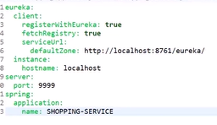

5. Run Eureka Server: Start your Spring Boot application configured as a Eureka Server.

6. Run Eureka Clients: Start your other Spring Boot services configured as Eureka Clients. They will automatically register with the Eureka Server and be available for discovery by other services.

**Que: What is Consul?**

**Ans:** Spring Cloud Consul allows Spring Boot applications to register themselves with a Consul server upon startup, making them discoverable by other services within the system. It also provides features for dynamic configuration management, allowing applications to retrieve configuration properties from Consul's key-value store.

Consul is developed by HashiCorp.

In simple terms, Consul is a tool that helps manage and connect different parts of a software application, especially in large-scale or distributed systems. It acts as a kind of "phone book" or directory for services, allowing them to find and communicate with each other easily.

Here's how Consul works:

**1. Service Discovery:** When a new service starts up, it registers itself with Consul, providing information like its name, address, and health status.

**2. Service Lookup:** Other services can query Consul to find out where a particular service is located. Consul keeps track of all registered services and their locations.

**3. Health Checking:** Consul regularly checks the health of registered services. If a service becomes unhealthy or unavailable, Consul can automatically remove it from the directory so that other services don't try to communicate with it.

**4. Key-Value Store:** Consul also provides a simple key-value store, which can be used for configuration management or storing other types of data.

**Que: What is the difference between Eureka and Consul?**

**Ans:**

**Eureka:**

* Part of Netflix OSS ecosystem.
* Client-server architecture.
* Focuses on service discovery.
* Widely adopted in Netflix and Spring Cloud environments.

**Consul:**

* Developed by HashiCorp.
* Distributed architecture.
* Offers service discovery and more (e.g., distributed key-value store, Consul Connect).
* Popular in DevOps and broader infrastructure communities.

**Que: What is Load Balancing?**

Ans: In Spring Boot, load balancing typically refers to the distribution of incoming requests among multiple instances of a service or application to optimize resource utilization, improve performance, and ensure high availability. Spring Boot itself doesn't provide built-in load balancing capabilities, but it can be easily integrated with other technologies or components that offer load balancing functionality.

Tools: Nginx and HAProxy, AWS Elastic Load Balancer.

Load balancing means spreading out tasks or requests across multiple computers, servers, or resources. This helps to prevent any single computer from becoming overwhelmed with too much work, ensuring that everything runs smoothly and quickly.

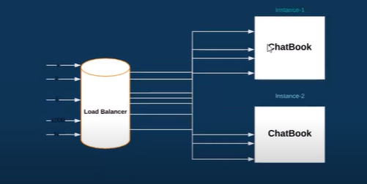

* **Scenario:** You have a Spring Boot application deployed on multiple servers, and you're using a load balancer to distribute incoming requests among them. However, you notice that one of the servers is receiving significantly more traffic than the others, causing performance issues. How would you address this imbalance?

**Answer:** One approach to address this imbalance is to adjust the load balancing algorithm used by the load balancer. For example, you could switch from a round-robin algorithm to a weighted algorithm, where each server is assigned, a weight based on its capacity or performance. This would allow you to distribute more traffic to the underutilized servers and reduce the load on the overloaded server.

* **Scenario:** You're deploying a Spring Boot application in a cloud environment with auto-scaling capabilities. How would you ensure that new instances launched by the auto-scaling system are automatically included in the load balancing pool?

**Answer:** To ensure that new instances launched by the auto-scaling system are automatically included in the load balancing pool, you would configure the auto-scaling group to register new instances with the load balancer upon launch. This typically involves setting up integration between the auto-scaling group and the load balancer, either through cloud provider-specific configurations or using APIs provided by the load balancer service.

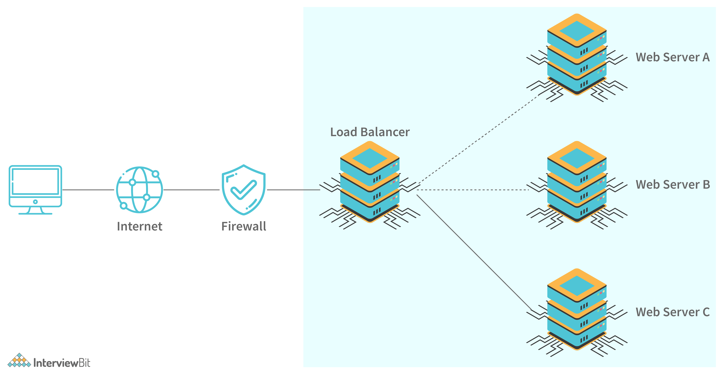

**Que: What are Load Balancing Algorithm?**

**Ans: Load balancing algorithms are techniques used to distribute incoming requests or workload across multiple servers or resources in a load balancing system.**

* Round Robin: In the Round Robin algorithm, requests are distributed sequentially in a circular manner among the available servers. Each new request is assigned to the next server in the list, looping back to the first server once all servers have been used. Round Robin is simple and evenly distributes the load across servers but doesn't consider server capacity or current load.
* Weighted Round Robin: Weighted Round Robin is an extension of the Round Robin algorithm that assigns a weight to each server based on its capacity or performance. Servers with higher weights receive more requests compared to servers with lower weights. This allows for better load distribution and can be used to prioritize certain servers over others.
* Least Connections: The Least Connections algorithm assigns incoming requests to the server with the fewest active connections at the time of the request. This ensures that requests are evenly distributed based on the current load on each server. However, it may lead to uneven load distribution if servers have varying processing capabilities.
* Weighted Least Connections: Weighted Least Connections is similar to the Least Connections algorithm but takes into account the capacity or performance of each server by assigning weights. Servers with higher weights are favored over servers with lower weights when selecting the server with the least connections. This helps balance the load more effectively based on both current connections and server capacity.
* IP Hash: In the IP Hash algorithm, the client's IP address is used to determine which server to route the request to. A hash function is applied to the client's IP address, and the result is used to select a server from the pool of available servers. This ensures that requests from the same client are always directed to the same server, useful for maintaining session affinity or statefulness.

**Que: What is Ribbon?**

**Ans:** Ribbon is a client-side load balancing library developed by Netflix and integrated with Spring Cloud. It is designed to provide resilience and load balancing capabilities to client applications, making it easier to build robust and scalable microservices architectures.

Ribbon uses various load balancing algorithms, such as Round Robin and Least Connections, to distribute requests effectively among the available service instances.

By default, Ribbon uses the Round Robin algorithm for load balancing.

**Que: How to Implement Ribbon?**

**Ans:** To implement Ribbon in a Spring Boot project, you typically follow these steps:

1. Add Dependencies: Add the Ribbon dependency to your pom.xml file to include it in your project's dependencies.

2. Enable Ribbon Client: Annotate a RestTemplate bean with @LoadBalanced to enable Ribbon as a load balancer for RestTemplate in your Spring Boot application.

3. Use RestTemplate with Ribbon: Inject the load-balanced RestTemplate bean into your service classes and use it to make requests to the target service. Ribbon will automatically choose an available instance of the service based on its load balancing algorithm.

4. Configure Service Instances: Ensure that your target service instances are registered with a service registry (e.g., Eureka) or configured to be discovered by Ribbon. Ribbon will fetch the list of available service instances from the service registry and use them for load balancing.

5. Run Your Application: Start your Spring Boot application. Ribbon will automatically handle load balancing of requests to the target service instances.

Remarks: The **@LoadBalanced** annotation is a part of Spring Cloud and is used in conjunction with the RestTemplate or WebClient bean to enable client-side load balancing. When you annotate a RestTemplate or WebClient bean with @LoadBalanced, Spring Cloud injects a load-balanced version of the bean into your application context.

**Que: What is Spring Cloud Config Server?**

**Ans:** Spring Cloud Config Server is a component of the Spring Cloud framework that provides centralized configuration management for distributed systems and microservices architectures. It allows you to externalize and manage your application configuration in a centralized, version-controlled repository, such as Git, SVN, or a file system.

**For Example:** Sure! Imagine you have a lot of different programs running on your computer, like games, office software, and web browsers. Each of these programs needs specific settings to work properly, like the language it should use or where it should store files.

Now, instead of storing these settings directly in each program, Spring Cloud Config Server lets you keep all these settings in one place, like a special folder on your computer. This folder is like a master control center for all your programs' settings.

With Spring Cloud Config Server, your programs can ask this control center for their settings whenever they start up. This way, if you ever need to change a setting, like the language for all your programs, you only have to do it in one place, and all your programs will get the update automatically the next time they start.

**Que: How to setup Spring Cloud Config Server in Spring Boot Project?**

**Ans:** Below is a simplified guide to help you get started:

1. Add Dependencies:

In your Spring Boot project's pom.xml file.

***<dependency>***

***<groupId>org.springframework.cloud</groupId>***

***<artifactId>spring-cloud-starter-config</artifactId>***

***</dependency>***

***<dependency>***

***<groupId>org.springframework.cloud</groupId>***

***<artifactId>spring-cloud-starter-netflix-eureka-client</artifactId>***

***</dependency>***

2. Configure Application Properties:

Create or update your application.properties

3. Enable Spring Cloud Config Server:

Annotate your main Spring Boot application class with @EnableConfigServer to enable Spring Cloud Config Server.

4. Store Configuration Files:

Store your application's configuration files (e.g., application.properties, application.yml) in a Git repository or any other supported version control system. The files should be organized based on profiles and application names.

5. Access Configuration:

Your Spring Boot applications can now access their configurations from the Spring Cloud Config Server by specifying the server's URL and the application's name in their bootstrap.properties.

* **Scenario**: You are developing a microservices architecture using Spring Boot, and you want to centralize your application configuration to simplify management. How would you use Spring Cloud Config Server to achieve this?
* **Answer**: With Spring Cloud Config Server, I would set up a separate Spring Boot application configured as a Config Server. This Config Server would connect to a version-controlled repository, such as Git, where I would store all my application configuration files. Each microservice in my architecture would then be configured as a Config Client, fetching its configuration from the Config Server at startup. This way, I can manage and update configuration settings in one central location, promoting consistency and simplifying maintenance across all microservices.
* **Scenario:** You have multiple environments (e.g., development, staging, production) for your Spring Boot applications, each with its own set of configuration properties. How would you organize and manage environment-specific configurations using Spring Cloud Config Server?
* **Answer:** I would organize my configuration files in the version-controlled repository (e.g., Git) based on profiles and application names. For example, I could have separate directories for each environment (e.g., dev, staging, prod), and within each directory, I would store configuration files named after the respective Spring Boot application, suffixed with the environment name (e.g., application-dev.properties, application-staging.properties, application-prod.properties). Spring Cloud Config Server would then serve the appropriate configuration properties based on the active profile of each microservice, ensuring that each environment receives its specific configuration.
* **Scenario:** You are experiencing performance issues with your Spring Cloud Config Server due to a high volume of configuration requests from client applications. How would you optimize the performance and scalability of the Config Server?
* **Answer:** To optimize the performance and scalability of the Config Server, I would consider implementing caching mechanisms to reduce the number of requests hitting the server. This involves caching configuration properties in memory or using distributed caching solutions like Redis or Hazelcast. Additionally, I would scale out the Config Server horizontally by deploying multiple instances behind a load balancer to handle increased traffic and distribute the workload effectively. Furthermore, I would monitor and tune the Config Server's resource utilization, such as memory and CPU usage, to ensure optimal performance under varying loads.

**Que: What is Spring Cloud Feign Client?**

**Ans:** Spring Cloud Feign is a declarative web service client library provided by Spring Cloud. It simplifies the process of creating RESTful web service clients by allowing you to define interfaces that represent the remote API endpoints.

Imagine you have a Java application, and you want it to talk to another application or service on the internet, like a weather API or a payment gateway. Usually, you'd have to write a lot of code to make these connections, handle errors, and process the responses.

Spring Cloud Feign simplifies this process. Instead of writing all that code yourself, you define simple interface files that describe what each service does. These interfaces act as blueprints for your interactions with the other services.

Then, with just a few annotations, Spring Cloud Feign automatically generates all the code needed to actually make those requests and handle the responses. This saves you from writing a ton of boilerplate networking code and makes it much easier to connect your Java application to other services on the internet.

**Que: How to implement Feign Client in You Project?**

**Ans:** Below is a simplified guide to help you get started:

1. Add Dependencies: First, you need to include the necessary dependencies in your pom.xml.

2. Enable Feign Client: You need to enable Feign client functionality in your Spring Boot application. Typically, this is done by adding @EnableFeignClients annotation to your main application class or a configuration class.

3. Define Feign Client Interface: Create an interface that defines the contract for communicating with the remote service. This interface should be annotated with @FeignClient and declare methods corresponding to the desired HTTP requests.

Remarks:

The @FeignClient annotation is a key component of Spring Cloud Feign, a declarative web service client library provided by Spring Cloud. It is used to declare a Feign client interface, which defines the contract for communicating with a remote HTTP-based service.

4. Use Feign Client in Service: Inject the Feign client interface into your service classes and use it to make requests to the remote service.

**Que: What is API Gateway?**

**Ans**: In Spring Cloud, an API Gateway is a centralized entry point for managing and routing incoming requests from clients to various microservices within a distributed system. It serves as a single point of entry for all client requests and provides a range of functionalities such as routing, filtering, load balancing, security, monitoring, and more.

The key functions of an API Gateway are:

* **Routing**: Routes incoming requests to the appropriate microservices based on predefined rules.
* **Load balancing:** Distributes incoming requests across multiple instances of the same microservice for scalability and reliability.
* **Security**: Enforces authentication, authorization, and other security policies at the edge of the system.
* **Filtering**: Intercepts incoming requests and outgoing responses to apply filters for tasks like logging, monitoring, and rate limiting.
* **Monitoring** **and analytics:** Collects data about incoming requests and outgoing responses for monitoring, tracking performance, and diagnosing issues.
* **API composition:** Aggregates data from multiple microservices and exposes it as a unified API to clients.

**Que: What is Zuul?**

**Ans:** Zuul is a powerful and versatile edge service component in the Netflix OSS ecosystem, which is used for building dynamic routing, monitoring, resiliency, security, and more in microservices architectures. It functions as an API gateway, sitting between client devices and backend services.

Zuul is like a gateway or a guard for your microservices. Imagine you have many different services running, each responsible for handling different parts of your application. Zuul sits in front of these services and manages all the requests coming in from users or clients.

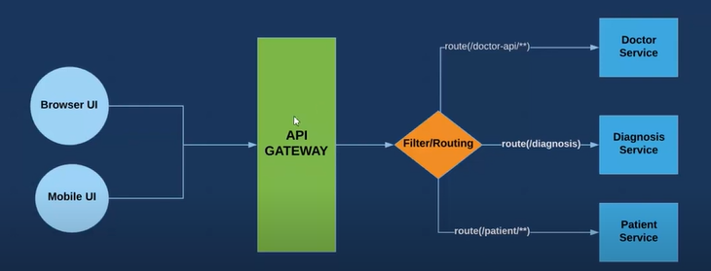

Here's what Zuul does:

**1. Routing:** When a request comes in, Zuul decides where it should go. It looks at the request and forwards it to the appropriate service based on certain rules you've set up.

**2. Load Balancing:** Zuul can distribute incoming requests across multiple instances of the same service to make sure no single instance gets overwhelmed with too much traffic.

**3. Filtering**: Zuul can intercept requests and responses and apply filters to them. For example, you can use filters to add authentication, logging, monitoring, or any other functionality you need.

**4. Security:** Zuul can enforce security policies at the edge of your microservices architecture. It can authenticate users, authorize access to certain resources, and protect against common security threats like attacks and abuse.

**5.Monitoring and Metrics:** Zuul can collect data about incoming requests and outgoing responses, such as response times, error rates, and more. This helps you monitor the health and performance of your services and diagnose issues when they arise.

**Que: How to Implement ZUUL?**

**Ans:** To implement Zuul in a Spring Boot project, you typically follow these steps:

1. Add Zuul Dependency: First, you need to include the Zuul dependency in your pom.xml.

2. Enable Zuul Proxy: You need to annotate your main Spring Boot application class with @EnableZuulProxy to enable Zuul in your application.

3. Configure Routing: By default, Zuul will forward requests to services based on their service IDs. You can configure routing rules in your application.properties or application.yml file to customize the routing behavior.

***zuul:***

***routes:***

***users-service:***

***path: /users/\*\****

***serviceId: users-service***

4. Run Your Application: Start your Spring Boot application. Zuul will start up and begin routing incoming requests based on your configuration.

**Que: What is Single Sign-0n ?**

**Ans:** Single Sign-On (SSO) is an authentication process that allows users to access multiple applications or services with a single set of login credentials. In Spring Boot, Single Sign-On can be implemented using Spring Security along with OAuth2 or OpenID Connect protocols.

Here's how it works in brief:

**1. User Authentication:** When a user tries to access an application, they are redirected to a centralized authentication server (the Identity Provider or IdP). The IdP prompts the user to enter their credentials (username and password) or uses another authentication mechanism such as social login.

**2. Token Generation:** Upon successful authentication, the IdP generates a security token (such as an OAuth2 access token or an OpenID Connect ID token) and sends it back to the application.

**3. Token Verification**: The application validates the received token with the IdP to ensure its authenticity and integrity. This process usually involves verifying the token's signature and expiration time.

**4. Access Granted:** If the token is valid, the application grants access to the user, allowing them to use the application's features and resources without requiring them to log in again.

**5. Session Management:** The application may maintain a session for the user to store user-specific data or preferences. This session is typically associated with the user's authentication token and is used to track the user's interactions with the application.

**Que: How you can achieve SSO?**

**Ans**: This How to achieve this:

Set up an Identity Provider (IdP): Choose an Identity Provider that supports OAuth2 or OpenID Connect protocols. Common options include Okta, Keycloak, Auth0, or even custom implementations using Spring Security OAuth2.

**1. Configure Spring Security:** Configure Spring Security in your Spring Boot application to integrate with the chosen IdP. You'll typically need to configure authentication providers, security filters, and authentication endpoints to handle the authentication flow.

**2. Enable OAuth2 or OpenID Connect**: Depending on your choice of IdP, you'll need to configure your application to use either OAuth2 or OpenID Connect for authentication. Spring Security provides support for both protocols out of the box, making it easy to integrate with various IdPs.

**3. Handle Redirects and Callbacks:** Implement logic to handle redirects from your application to the IdP's login page for authentication, as well as callbacks from the IdP to your application with authentication tokens.

**4. Secure Your Resources:** Once the user is authenticated, secure your application's resources (e.g., endpoints, APIs) using Spring Security's authorization mechanisms. You can define access control rules based on user roles or permissions.

**5. Test Your SSO Setup:** Test your SSO setup thoroughly to ensure that users can log in seamlessly and access the application's resources securely.

**Que: What is OAuth?**

**Ans:** OAuth 2.0 (Open Authorization 2.0) is an authorization framework that enables third-party applications to obtain limited access to a user's protected resources on a server, such as a web service, without the need for the user's credentials to be shared directly. It is widely used for secure API authorization in various scenarios, including web and mobile applications.

**Que: What is Okta ?**

**Ans:** Okta is a popular cloud-based identity management platform that provides authentication, authorization, and user management services for web and mobile applications. It offers a comprehensive set of features for securing access to applications and resources, managing user identities, and ensuring compliance with security policies.

Some key features and capabilities of Okta's authentication services:

**1. Single Sign-On (SSO):** Okta enables Single Sign-On, allowing users to access multiple applications with a single set of credentials. Once authenticated, users can seamlessly access other applications without needing to log in again.

**2. Multi-Factor Authentication (MFA):** Okta supports various methods of multi-factor authentication, such as SMS, email, push notifications, time-based one-time passwords (TOTP), and biometric authentication.

**3. User Management:** Okta provides user lifecycle management capabilities, including user provisioning, deprovisioning, and synchronization with external directories such as Active Directory and LDAP. Administrators can manage user accounts, groups, roles, and permissions from a centralized dashboard.

**4. Audit and Reporting:** Okta provides comprehensive audit logs and reporting capabilities, allowing organizations to track user authentication events, access activities, and policy violations.

**Que: What is Spring Cloud Function?**

**Ans:** Spring Cloud Function is a project within the Spring ecosystem that allows developers to build and deploy serverless applications using Spring Boot and Spring Cloud. It provides a programming model for writing functions as Spring beans and deploying them to serverless platforms like AWS Lambda, Azure Functions, Google Cloud Functions, or any other environment that supports serverless computing.

**Que: What is Server-less Architecture?**

**Ans:** Serverless computing, also known as serverless architecture or function as a service (FaaS), is a cloud computing model where the cloud provider manages the infrastructure and dynamically allocates resources to execute code in response to events or requests. In a serverless architecture, developers write and deploy functions (small units of code) without having to manage the underlying servers or infrastructure.

Key Characteristics:

1. No server management.

2. Event Driven Execution

3. Pay-per-use Pricing

4. Scalability and Elasticity

5. switch among cloud provider.

**Que: What is Pivotal Cloud Foundry (PCF)?**

**Ans:** Pivotal Cloud Foundry (PCF) is a cloud-native platform that simplifies the deployment, management, and scaling of applications in cloud environments. It is designed to accelerate the development and delivery of software by providing a consistent and automated platform for deploying and running applications across various cloud infrastructures.

**Que: What are some common Spring Cloud Annotation you have used in you project?**

**Ans:** Spring Cloud provides several annotations that simplify the development of microservices applications. Some common annotations include:

1. **@EnableDiscoveryClient:** Enables service discovery for your Spring Boot application. It allows the application to register itself with a service registry (such as Eureka, Consul, etc.) and discover other services registered with the same registry.
2. **@FeignClient:** Declares a Feign client interface, which is used to make HTTP requests to other services in a declarative manner. Feign simplifies RESTful client creation by allowing you to write Java interfaces that map to HTTP APIs.
3. **@LoadBalanced:** Marks a RestTemplate or WebClient bean to be automatically configured with client-side load balancing. It works in conjunction with service discovery and client-side load balancing libraries (such as Ribbon) to distribute requests across multiple instances of a service.
4. **@EnableCircuitBreaker:** Enables circuit breaker functionality for your Spring Boot application. Circuit breakers help prevent cascading failures by providing fallback behavior when a service is unavailable or experiencing issues.
5. **@EnableConfigServer:** Enables the Spring Cloud Config Server, allowing your application to serve configuration properties to other applications over HTTP or other protocols.
6. **@RefreshScope:** Marks a bean for dynamic reloading of its configuration properties from a configuration source (e.g., Spring Cloud Config Server) when the /refresh endpoint is invoked.
7. **@EnableOAuth2Client:** Enables OAuth2 client functionality in your Spring Boot application. It allows your application to interact with OAuth2-protected resources on behalf of the user.
8. **@EnableResourceServer:** Enables OAuth2 resource server functionality in your Spring Boot application. It allows your application to secure its endpoints using OAuth2 tokens.

**Que: What is difference between Ribbon and Zuul in Spring Cloud Framework?**

**Ans:** Ribbon and Zuul are two components of the Spring Cloud framework that serve different purposes in building microservices architectures:

**Ribbon:**

* Ribbon is a client-side load balancing library that provides client-side load balancing for HTTP and TCP-based services.
* It operates at the client-side, meaning that it is embedded within the client application.
* Ribbon allows client applications to distribute incoming requests across multiple instances of a service, improving fault tolerance, scalability, and performance.
* It uses various load balancing algorithms (such as Round Robin, Random, Least Connection) to distribute traffic among service instances.
* Ribbon integrates seamlessly with Spring Cloud applications and can be easily configured using annotations or configuration properties.

**Zuul:**

* Zuul is an edge service or API gateway component that provides dynamic routing, filtering, and load balancing for microservices architectures.
* It operates at the server-side, meaning that it sits between client applications and backend services.
* Zuul acts as a reverse proxy, receiving incoming requests from clients and routing them to the appropriate backend services based on predefined routing rules.
* It supports features such as request routing, request filtering, load balancing, authentication, authorization, and rate limiting.
* Zuul can be used to implement cross-cutting concerns such as security, logging, monitoring, and traffic management in a centralized manner.
* Zuul integrates with service discovery components (such as Eureka) to dynamically discover backend services and update routing rules accordingly.

**Que: What is Splunk?**

**Ans:** Using Splunk you can track real time log of you application. Splunk is an extremely powerful platform that is used to analyze data and logs produced by application. Splunk allows you to monitor, search and analyze data and logs through a web interface.

When you develop an app then the whole log are saved in one file which is bad practice. So, we implement Splunk which will create different log file for each microservices.

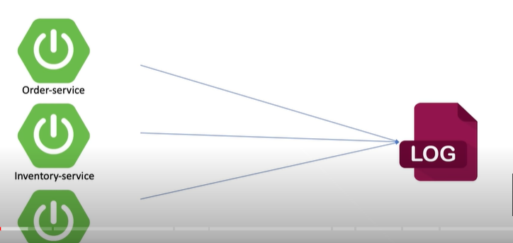🡪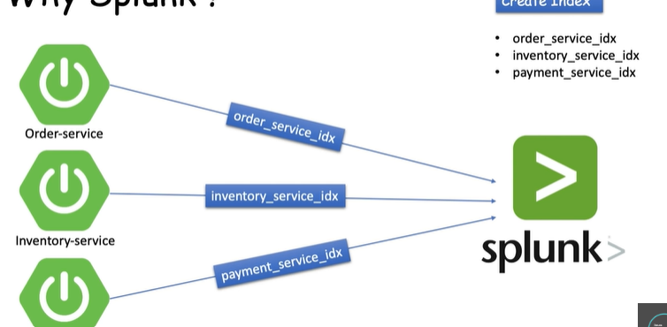

Splunk is a powerful and widely-used software platform designed for searching, monitoring, analyzing, and visualizing machine-generated data in real-time. It provides organizations with a centralized platform to index, search, and correlate data from various sources, including applications, servers, networks, sensors, and more.

**Key features and capabilities of Splunk include:**

* Data Collection: Splunk can collect and index data from a wide range of sources, including log files, metrics, events, databases, APIs, and streaming data.
* Search and Analysis: Splunk's search language allows users to perform ad-hoc searches and complex queries to explore and analyze data. It supports real-time searching, correlation, and visualization of results.
* Visualization and Dashboards: Splunk provides powerful visualization tools to create interactive dashboards, charts, graphs, and reports to visualize data trends, patterns, and insights.
* Alerting and Monitoring: Splunk can generate alerts and notifications based on predefined criteria or anomalies detected in the data. It enables proactive monitoring and alerting for operational issues, security threats, and performance metrics.
* Machine Learning and AI: Splunk offers machine learning (ML) and artificial intelligence (AI) capabilities to automate data analysis, detect patterns, predict trends, and provide actionable insights.
* Security and Compliance: Splunk can be used for security monitoring, threat detection, incident response, and compliance reporting. It helps organizations improve their cybersecurity posture and meet regulatory requirements.
* Integration and Extensibility: Splunk integrates with a wide range of third-party tools, technologies, and data sources through APIs, connectors, and plugins. It supports customization and extensibility to meet specific use cases and requirements.

**Que: What is Splunk Forwarder and Filter Criteria’s?**

**Ans:** Splunk Forwarder, also known as Splunk Universal Forwarder, is a lightweight component of the Splunk platform that is used to collect, forward, and index data from various sources into a Splunk deployment.

**Data Forwarding:**

Once data is collected, Splunk Forwarder forwards the data securely and efficiently to a centralized Splunk deployment.

It uses various protocols like TCP, UDP, HTTP, or HTTPS for data forwarding, depending on the configuration and security requirements.

In Splunk, filter criteria refers to the rules and conditions used to narrow down or refine the search results when querying and analyzing data. Filter criteria help users focus on specific data subsets or events of interest within the larger dataset, allowing for more targeted and efficient data analysis.

**Que: How to implement Splunk in spring boot project?**

**Ans:**

1. Add Splunk Dependency:

Add the Splunk Logback dependency to your Spring Boot project's pom.xml.

2. Configure Splunk Logging:

In your Spring Boot application's application.properties file, configure Splunk.

3. Create Logback Configuration:

Create a logback-spring.xml file in the src/main/resources directory to configure Logback for Splunk logging.

4. Replace Splunk Configuration:

Replace placeholders (<splunk_server_host>, <splunk_server_port>, YourSplunkToken, YourAppSource, YourAppSourceType, YourAppIndex) in the Logback configuration with your actual Splunk server details and configuration.

5. Logging in Spring Boot:

In your Spring Boot application code, use standard logging APIs like java.util.logging, org.slf4j.Logger, or org.apache.commons.logging.Log for logging messages.

6. Run and Monitor:

Run your Spring Boot application, and it will start logging messages to both the console and Splunk based on the Logback configuration.

**Que: What is Vertical Scaling and Horizontal Scaling?**

**Ans:**

**Vertical Scaling (Scaling Up):**

* Imagine you have a computer with limited processing power (CPU), memory (RAM), and storage. Vertical scaling means upgrading this computer's hardware components to increase its capacity and performance.
* For example, if you add more RAM or upgrade the CPU to a faster one, you're vertically scaling the computer.
* Pros: Easy to understand and manage, suitable for small to medium-sized applications.
* Cons: Limited scalability as there's a maximum limit to how much one computer can handle, can be costly for high-end configurations.

**Horizontal Scaling (Scaling Out):**

* Now, think of multiple computers working together to handle a large workload. Horizontal scaling involves adding more computers (nodes or instances) to the system to share the workload and increase capacity.
* For instance, if you have a website that gets a lot of visitors, you can add more servers and use a load balancer to distribute incoming requests among these servers. This is horizontal scaling.
* Pros: Highly scalable as you can keep adding more servers to handle increasing demand, fault-tolerant (if one server fails, others can still handle requests), no downtime for scaling.
* Cons: More complex to manage multiple servers, requires proper load balancing and coordination.

**In simpler terms:**

* Vertical scaling is like upgrading your computer to make it faster and more powerful.
* Horizontal scaling is like adding more computers to share the workload and handle more users or requests.

**When deciding between vertical and horizontal scaling:**

* Vertical scaling is suitable for smaller applications with predictable growth and moderate resource requirements.
* Horizontal scaling is better for large-scale applications, high traffic websites, or systems with unpredictable workloads that need to handle a lot of concurrent users or requests.

**Remarks :*8 replace 16-- replace 32, horizontal-- 8,,, extend 8+8,, then 8+8+8i.ee three machine.***

**Que: What is difference between application.properties and application.yaml ?**

**Ans:**

application.properties and application.yaml are configuration files commonly used in Spring Boot applications to define application properties, settings, and environment-specific configurations. They provide a convenient way to externalize configuration from the code, allowing developers to modify settings without modifying the application's source code.

**1. application.properties:**

* application.properties is a properties file format used to define key-value pairs of configuration properties.
* Each property is specified in the format key=value.
* Example application.properties file:

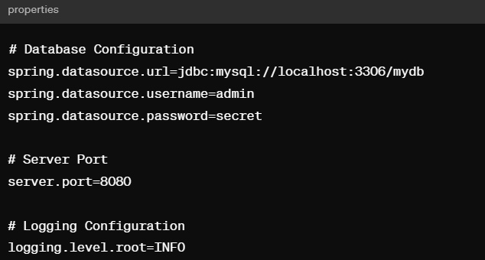

**2. application.yaml (or application.yml):**

* application.yaml (or application.yml) is a YAML (YAML Ain't Markup Language) file format used to define configuration properties hierarchically using indentation.
* YAML syntax allows for a more structured and readable representation of configuration properties compared to properties files.
* Example application.yaml file:

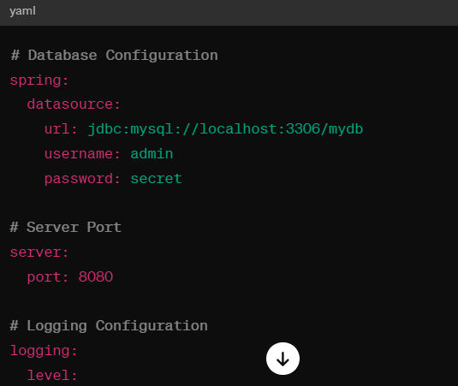

**Common configurations that can be specified in these files include:**

* Database connection properties (e.g., datasource URL, username, password)
* Server configurations (e.g., port number, context path)
* Logging levels and configurations (e.g., log levels for different packages or components)
* Environment-specific properties (e.g., profiles, active profiles).

**Which to use when?**

**Use application.properties when:**

* You have simple configurations like key-value pairs (e.g., server.port=8080).
* Your configuration is flat and doesn't need nesting or hierarchy.
* You're more familiar with the properties file format.

**Use application.yaml when:**

* You need nested or hierarchical configurations (e.g., for databases or complex settings).
* Readability is important, especially for complex configurations.
* You want to avoid duplicating properties by using variables or reusing common properties.
* You need to define conditional profiles or configurations based on environments.

**Que: What is Swagger UI?**

Ans: Swagger UI is a tool that allows developers to visualize and interact with APIs (Application Programming Interfaces) in a user-friendly and interactive manner. It's part of the Swagger toolset, which includes the Swagger Editor, Swagger Codegen, and other tools aimed at simplifying API development and documentation.

Here are key points about Swagger UI:

1. **Interactive API Documentation:** Swagger UI generates a web-based interface that displays API documentation in a structured and interactive format. It includes details about API endpoints, request parameters, response formats, and authentication methods.
2. **Testing Endpoints:** Developers can use Swagger UI to test API endpoints directly from the browser. It provides a convenient way to send requests and view responses without needing a separate API testing tool.
3. **Code Generation:** Swagger UI can generate client SDKs (Software Development Kits) for various programming languages based on the API definition. This allows developers to quickly integrate APIs into their applications using generated code.
4. **OpenAPI Specification:** Swagger UI is built on top of the OpenAPI Specification (formerly Swagger Specification), which is a standard format for describing RESTful APIs. The OpenAPI Specification defines the structure of API documentation, making it easier for developers to understand and work with APIs.
5. **Customization:** Swagger UI allows for customization of the UI appearance, themes, and settings. Developers can tailor the UI to match their branding or specific requirements.
6. **Integration with Swagger Editor:** Swagger UI is often used alongside the Swagger Editor, which is a tool for designing and editing OpenAPI specifications. Changes made in the Swagger Editor can be visualized instantly in Swagger UI, providing a seamless workflow for API development and documentation.

Overall, Swagger UI enhances the developer experience by providing a comprehensive and interactive view of APIs, enabling easier testing, documentation, and integration of APIs into applications. It's widely used in the API development community and is supported by various API management platforms and frameworks.

Integrating Swagger UI into a Spring Boot project involves adding the necessary dependencies, configuration, and annotations to enable API documentation and visualization. Here's a step-by-step guide to integrating Swagger UI in a Spring Boot project:

**1. Add Swagger Dependencies:**

* In your pom.xml file (if using Maven) or build.gradle file (if using Gradle), add the necessary dependencies for Swagger and Swagger UI.

**2. Enable Swagger in Spring Boot Application:**

* Create a new Java class or use an existing one annotated with @SpringBootApplication to configure Swagger in your Spring Boot application. Add the @EnableSwagger2 annotation to enable Swagger support.

**3. Swagger Configuration:**

* Create a new Java class to configure Swagger settings. Annotate this class with @Configuration and create a Docket bean to customize the API documentation.

**4. Run and Access Swagger UI:**

* Start your Spring Boot application, and once it's running, you can access Swagger UI by navigating to the following URL in your web browser:

**Spring Security**

**Que: What are Spring Security?**

**Ans:** Spring Security is a powerful and highly customizable authentication and access control framework provided by the Spring Framework for Java applications. It focuses on securing web applications by providing comprehensive security features and functionalities.

Key Features of Spring Security:

**1. Authentication:**

* Authentication is the process of verifying the identity of users attempting to access the application. Spring Security supports various authentication mechanisms, including username/password authentication, LDAP authentication, OAuth, and more.
* It provides authentication providers, such as DaoAuthenticationProvider, LDAP authentication provider, and custom authentication providers, to validate user credentials.

**2. Authorization:**

* Authorization determines what actions and resources a user is allowed to access within the application. Spring Security enables fine-grained access control through role-based access control (RBAC), expression-based access control, and method-level security annotations.

**3. Web Security:**

* Spring Security integrates seamlessly with Spring MVC and provides robust security configurations for web applications. It offers features like CSRF protection, session management, secure headers, and request/response filtering.
* You can configure URL-based access control, restrict access to specific endpoints, and handle authentication and authorization exceptions gracefully.

**4. Integration with Authentication Providers:**

* Spring Security supports integration with various authentication providers, such as databases, LDAP directories, OAuth providers (Google, Facebook, etc.), and custom authentication mechanisms.

**5. Security Filters and Interceptors:**

* Spring Security leverages servlet filters and interceptors to enforce security policies and perform authentication and authorization checks at different stages of the request processing pipeline.
* It includes filters like UsernamePasswordAuthenticationFilter, BasicAuthenticationFilter, and more for handling authentication tasks.

**6. Session Management:**

* Spring Security offers session management features to control and manage user sessions, including session fixation protection, session timeout handling, concurrent session control, and session tracking mechanisms.

**7. CSRF Protection:**

* Cross-Site Request Forgery (CSRF) protection is built into Spring Security to prevent CSRF attacks. It generates and validates CSRF tokens to ensure that requests originated from the application and not from malicious sources.

**8. Method-Level Security:**

* Spring Security provides annotations and configurations for securing methods and operations within the application. You can annotate methods with @Secured, @PreAuthorize, @PostAuthorize, etc., to enforce security constraints based on user roles and permissions.

**9. Customization and Extensibility:**

* Spring Security is highly customizable and extensible, allowing developers to tailor security configurations, implement custom authentication/authorization logic, integrate with third-party security providers, and handle complex security requirements.

**Que: What is method security and why do we need it?**

**Ans:** Method security in Spring Security refers to the ability to enforce security rules and access control restrictions at the method level within your application's code. It allows you to annotate methods with security rules that specify who can access the method based on roles, permissions, or other security attributes.

Here are the main method-level security annotations provided by Spring Security:

**1. @Secured:**

* @**Secured** is one of the simplest method-level security annotations.
* It allows you to specify a list of roles or authorities that are allowed to access the annotated method.
* Example: ***@Secured("ROLE_ADMIN") or @Secured({"ROLE_ADMIN", "ROLE_USER"}).***

**2. @PreAuthorize and @PostAuthorize(secure ke tarah hi hai lekin SPEL use krta hai)**

* @**PreAuthorize** and @**PostAuthorize** are more flexible than @Secured as they allow you to use SpEL (Spring Expression Language) to define complex security expressions.
* @**PreAuthorize** is used to specify security checks before entering a method, while @PostAuthorize is used for checks after the method has been executed.

***@PreAuthorize("hasRole('ADMIN') or hasRole('MANAGER')")***

***public void someMethod() {***

***// Method implementation***

**3**. @**PreFilter** **and** @**PostFilter**: (method me jo parameter dalte hai usko filter krta hai)

* @**PreFilter** and @**PostFilter** are used for filtering method parameters or return values based on security rules.
* @**PreFilter** allows you to filter incoming collections based on a security expression.
* @**PostFilter** filters the method's return value based on a security expression.

**4. @RolesAllowed:**

* @**RolesAllowed** is similar to @Secured but is part of the Java EE security standard (JSR-250).
* It specifies the roles allowed to access the method.
* Example: @**RolesAllowed**("ROLE_ADMIN") or @**RolesAllowed**({"ROLE_ADMIN", "ROLE_USER"}).

**5. @PreAuthenticated:**

* @**PreAuthenticated** is used to indicate that a method requires a pre-authenticated principal (user) to access the method.
* It is often used in combination with other authentication mechanisms, such as SSO (Single Sign-On) or external authentication providers.
* Let's assume you have a method in a service class that requires a pre-authenticated user to access some functionality. In this example, we'll create a simple service that allows users to retrieve their account details only if they are pre-authenticated (logged in).

**6. @Transactional (with security annotations):**

* Spring Security allows you to apply security annotations within transactional methods.
* This ensures that security checks are performed within the transactional context, providing consistent security enforcement.

**Que: What is SpEL (Spring Expression Language)?**

**Ans:** The Spring Expression Language (SpEL) is a powerful expression language that provides a standardized way to evaluate expressions within Spring applications. SpEL is used extensively in Spring frameworks, such as Spring Security, Spring Data, and Spring Integration, to configure and customize application behavior using expressions.

**Que: What is Authentication and Authorization?**

Ans: Authentication and authorization are two fundamental concepts in the field of information security, particularly when designing secure systems and applications. They are often used together to control access to resources and ensure that only authorized users can perform certain actions.

**Authentication:**

* Authentication is the process of verifying the identity of a user or entity. It answers the question, "Who are you?" and ensures that the person or system claiming an identity is indeed who they say they are. Authentication is typically performed during the login or sign-in process.

**Types of Authentications:**

* **Username and Password:** The most common form of authentication where users provide a username and password.
* **Multi-factor Authentication (MFA):** Requires users to provide two or more verification factors, such as a password, a one-time code sent to a mobile device, or a fingerprint scan.
* **Biometric Authentication:** Uses unique biological characteristics like fingerprints, iris scans, or facial recognition for authentication.
* **Token-Based Authentication:** Involves the use of tokens (e.g., JSON Web Tokens) for authentication instead of traditional credentials.

**Authentication Process:**

* The user provides credentials (username/password, token, biometric data, etc.) during login.
* The system verifies the provided credentials against stored or validated credentials.
* If the credentials are valid, the user's identity is confirmed, and access is granted.

**Authorization:**

* Authorization is the process of determining what actions or operations an authenticated user or entity is allowed to perform. It answers the question, "What are you allowed to do?" Authorization is based on the user's identity and the permissions or roles associated with that identity.

**Types of Authorization:**

* **Role-Based Access Control (RBAC):** Assigns permissions and access rights based on predefined roles (e.g., admin, user, manager).
* **Attribute-Based Access Control (ABAC):** Makes authorization decisions based on attributes of the user, resource, environment, and context.
* **Rule-Based Access Control:** Uses rules or policies to determine access rights (e.g., if-then conditions).
* **Discretionary Access Control (DAC):** Allows users to control access to their own resources.

**Authorization Process:**

* After successful authentication, the system checks the user's identity and retrieves their associated roles or permissions.
* The system compares the requested action or operation against the user's roles/permissions to determine if access should be granted or denied.
* If the user has the necessary permissions, access is granted; otherwise, access is denied, and an authorization error may be returned.

**WebSecurityConfigurerAdapter:**

* WebSecurityConfigurerAdapter is an abstract class provided by Spring Security that you can extend to create a custom security configuration for your application. By extending this class, you can override its methods to configure authentication, authorization rules, security filters, and other security-related settings.

**@EnableWebSecurity:**

* @EnableWebSecurity is an annotation that you can add to a configuration class to enable Spring Security's web security features. When you annotate a configuration class with @EnableWebSecurity, Spring Boot automatically applies the default security configuration provided by Spring Security for web applications.

**Que: What are type of Authentication?**

**Ans**: Knowledge-based authentication (KBA) and possession-based authentication are two different methods used in authentication systems to verify the identity of users. Here's an explanation of each:

**1. Knowledge-Based Authentication (KBA):**

* KBA relies on information that only the legitimate user should know to verify their identity. This information typically includes answers to specific questions or knowledge-based challenges.
* During KBA, users are asked to provide answers to pre-defined security questions, such as "What is your mother's maiden name?" or "Which city were you born in?"
* The system compares the provided answers against the expected answers stored in a secure database. If the answers match, the user's identity is verified.
* KBA is often used as an additional layer of security in conjunction with other authentication methods like username/password authentication or token-based authentication.

**2. Possession-Based Authentication:**

* Possession-based authentication verifies the user's identity based on something they possess, such as a physical token or a digital certificate.
* Common examples of possession-based authentication include:
* **Hardware Tokens**: Users carry physical devices (e.g., USB tokens, smart cards) that generate one-time passwords (OTPs) or cryptographic keys for authentication.
* **Mobile Authenticator Apps:** Users install mobile apps that generate time-based OTPs or receive push notifications for authentication purposes.
* **Digital Certificates:** Users possess digital certificates issued by a Certificate Authority (CA) that are used for client authentication in secure communication protocols (e.g., SSL/TLS).
* **Biometric Devices:** Users authenticate using biometric data (e.g., fingerprint, face recognition) stored on a physical device like a fingerprint scanner or facial recognition device.
* Possession-based authentication adds an extra layer of security by requiring users to have a physical or digital token in addition to their username/password or other credentials.

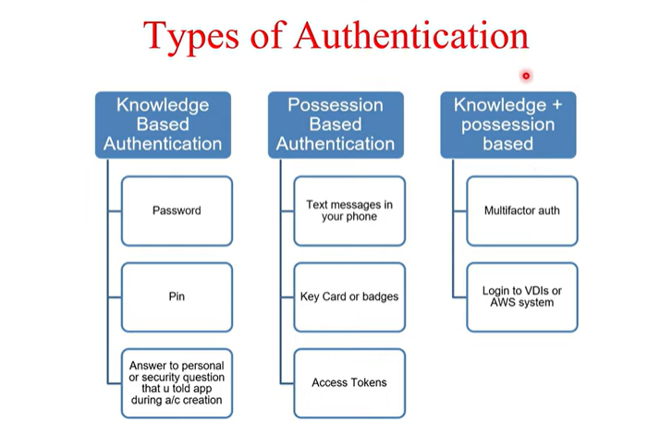

**Que: What do you mean by basic authentication?**

**Ans:** RESTful web services can be authenticated in many ways, but the most basic one is basic authentication. For basic authentication, we send a username and password using the HTTP [Authorization] header to enable us to access the resource. Usernames and passwords are encoded using base64 encoding (not encryption) in Basic Authentication. The encoding is not secure since it can be easily decoded.

**Basic authentication has some limitations and security considerations:**

* Base64 Encoding: Although the credentials are base64-encoded, they are not encrypted or hashed, so they can be easily decoded if intercepted. It's important to use HTTPS (HTTP Secure) to encrypt the entire communication to prevent credential sniffing.
* No Session Management: Basic authentication does not maintain session state on the server-side. Each request requires re-authentication with the username and password.
* Limited Security: While simple and widely supported, basic authentication may not provide sufficient security for highly sensitive applications or data. It is often used in combination with other authentication methods or as a temporary measure.

**Que: What do you mean by Digest Authentication?**

**Ans:** Digest authentication is an authentication mechanism used in HTTP (Hypertext Transfer Protocol) to securely authenticate users without sending their passwords in plaintext over the network. It is an improvement over basic authentication, which sends passwords in base64 encoding, making them vulnerable to interception and decoding.

It applies a hash function to username, password, HTTP method, and URI in order to send credentials in encrypted form. It generates more complex cryptographic results by using the hashing technique which is not easy to decode.

**Client Request:**

* When a client (such as a web browser or API client) sends a request to access a protected resource on a server, it includes the Authorization header in the HTTP request with a digest token.
* The digest token includes information such as the username, realm (authentication domain), nonce (a unique value generated by the server), URI (requested resource), response (a hash of the credentials and other data), and optional additional parameters.

**Client Response:**

* The client receives the server's challenge and constructs a response based on the received parameters, including the nonce, username, password (or a hashed version), realm, URI, and algorithm.
* The client calculates a hash (digest) of these values using a specified hashing algorithm (e.g., MD5, SHA-256) and sends the response in the Authorization header of the subsequent request.

**Que: How does Security flow?**

**Ans:**

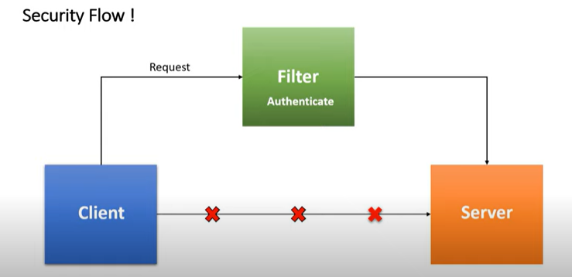

**Que: What is Spring Security Filter Chain?**

**Ans:** The Spring Security filter chain is a series of filters that are applied to incoming HTTP requests to enforce security policies, perform authentication, and authorize access to protected resources within a Spring Security-enabled application.

Here are key points about the Spring Security filter chain:

**1. Order of Filters:**

* The filter chain consists of a sequence of filters that are executed in a specific order during the processing of incoming HTTP requests.

**2. Security Filter Chain:**

* The core of Spring Security's filter chain is the SecurityFilterChain interface, which represents a chain of security-related filters applied to requests.
* Each SecurityFilterChain is responsible for handling requests that match a specific pattern or request URL pattern.

**3. Custom Filter Chain:**

* Developers can customize the Spring Security filter chain by defining and configuring additional filters based on their application's security requirements.

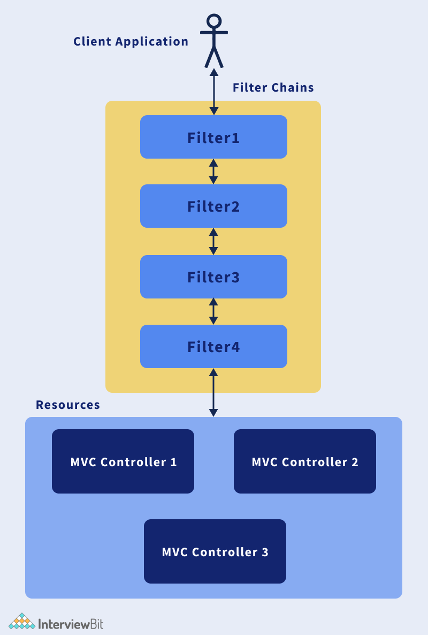

**Que: Name some predefined filters used in Spring Security?**

**Ans:** Here are some of the predefined filters used in Spring Security along with their functions:

**1. SecurityContextPersistenceFilter:**

Function: This filter is responsible for loading the SecurityContext from the session (or another persistent store) and saving it back after the request processing.

**2. LogoutFilter:**

* Function: Handles logout requests and performs logout operations, such as invalidating the session, clearing authentication details, and redirecting users to a logout success URL.

**3. UsernamePasswordAuthenticationFilter:**

* Function: Processes form-based login requests by extracting username and password parameters from the request, authenticating users using configured authentication providers and setting authentication details in the SecurityContext.

**4. BasicAuthenticationFilter:**

* Function: Handles HTTP Basic Authentication requests by extracting credentials from the Authorization header, authenticating users using configured authentication providers, and setting authentication details in the SecurityContext.
* It supports basic authentication where the client sends credentials (username and password) encoded in Base64 format in the request header.

**5. RememberMeAuthenticationFilter:**

* Function: Implements remember-me authentication functionality by processing remember-me token cookies from the request, validating remember-me tokens, and automatically authenticating users based on valid tokens.
* It allows users to stay authenticated across sessions by remembering their login credentials using remember-me tokens.

**6. AnonymousAuthenticationFilter:**

* Function: Provides anonymous (unauthenticated) access to certain resources or endpoints by setting up an anonymous authentication token in the SecurityContext for unauthenticated users.
* It allows unauthenticated users to access public or anonymous resources without requiring them to log in or provide credentials.

**7. ExceptionTranslationFilter:**

* Function: Handles security-related exceptions thrown during the request processing, such as access denied exceptions, authentication failures, and insufficient privileges.
* It translates security exceptions into appropriate HTTP responses (e.g., redirecting to login page, displaying access denied page) based on configured exception handling strategies.

**8. SessionManagementFilter:**

* Function: Manages user sessions, handles session creation, invalidation, and tracking, and enforces session-related security policies, such as session fixation protection, session concurrency control, and session timeout handling.

**Que: Explain DelegatingFilterProxy in spring security?**

**Ans**: DelegatingFilterProxy is a special filter provided by Spring Framework that delegates the actual filtering work to a Spring-managed bean (typically a Filter implementation) defined in the application context. It is commonly used in Spring applications, especially with Spring Security, to integrate custom filters into the servlet container's filter chain.

**Proxying Servlet Filters:**

DelegatingFilterProxy acts as a proxy for a target Filter bean managed by the Spring container. Instead of directly registering the target filter with the servlet container in the web.xml file, you declare DelegatingFilterProxy in the web.xml or as a Spring bean.

**Que: What do you mean by Session Management in Spring Security?**

**Ans:** Session management in Spring Security refers to the process of managing user sessions within a web application to maintain stateful interactions between the client (usually a web browser) and the server.

* It involves creating, tracking, and handling user sessions securely to ensure authentication and authorization are maintained throughout the user's interaction with the application.
* Session Management is one of the most critical aspects of Spring security as if sessions are not managed properly, the security of data will suffer.

Here are key aspects of session management in Spring Security:

**1. Session Creation:**

* When a user successfully authenticates (logs in) to the application, Spring Security creates a session to track the user's interaction.
* The session typically includes information such as the user's authentication details, session ID, roles, permissions, and any additional session attributes.

**2. Session Tracking:**

* Spring Security uses session tracking mechanisms to associate each user's session with a unique session ID. This ID is often stored in cookies, URL parameters, or hidden form fields and sent with each subsequent request from the client.
* The session ID allows the server to identify and retrieve the user's session data to maintain continuity during the user's visit to the application.

**3. Session Fixation Protection:**

* Session fixation is a security vulnerability where an attacker fixes (sets) a user's session ID to gain unauthorized access to the user's session.
* Spring Security offers protection against session fixation attacks by regenerating the session ID upon authentication, ensuring that the session ID changes after successful login.

**4. Session Invalidation and Logout:**

* When a user logs out or terminates their session, Spring Security invalidates the session to ensure that the user cannot access protected resources with the same session ID.
* Session invalidation may involve clearing session attributes, removing session data from storage, and notifying the client that the session has ended.

**5. Concurrent Session Control:**

* It is the number of sessions that an authenticated user can have open at once.
* Spring Security supports concurrent session control to limit the number of active sessions per user or restrict users from having multiple simultaneous sessions.
* You can configure maximum session limits and define how to handle concurrent session violations, such as allowing the most recent session and invalidating older sessions.

**6. Session Persistence:**

* Spring Security can integrate with various session persistence mechanisms, such as storing sessions in memory, using a distributed cache (e.g., Redis, Hazelcast), or persisting sessions to a database.
* Persistent sessions ensure session data is retained across server restarts and can be shared across multiple application instances in a clustered environment.

**Que: Explain SecurityContext and SecurityContext Holder in Spring security.**

**Ans:** In Spring Security, the SecurityContext and SecurityContextHolder play a fundamental role in managing and accessing security-related information, such as authentication details and granted authorities, within a web application.

**SecurityContext: (authenticated user ka sara information rakhta hai)**

* The SecurityContext interface represents the overall security information associated with a request or session in a Spring Security-enabled application.
* It typically contains the current authentication information, including the authenticated principal (user), granted authorities (roles), and any additional authentication details.
* The SecurityContext interface defines methods to get and set the authentication object (Authentication) representing the authenticated user's identity and credentials.

**SecurityContextHolder: (ye security context ko access krne ka tarika hai)**

The SecurityContextHolder class provides a way to access and manage the SecurityContext associated with the current thread of execution.

It serves as a central holder for the SecurityContext within the application's runtime environment, ensuring that security-related information is available throughout the request processing lifecycle.

The SecurityContextHolder class provides static methods to set, get, and clear the SecurityContext associated with the current thread.

**Que: Explain AuthenticationManager in Spring security?**

**Ans:** In Spring Security, the AuthenticationManager interface is a core component responsible for authenticating (verifying) the identity of users based on their credentials, such as usernames and passwords. It acts as the central entry point for handling authentication requests and delegating the authentication process to one or more configured authentication providers.

**Authentication Flow:**

* When an authentication request is received, the AuthenticationManager iterates through its configured AuthenticationProvider instances in sequence until a provider successfully authenticates the user or all providers have been exhausted.
* Each AuthenticationProvider checks if it supports the authentication request (based on the authentication type or provider-specific criteria) and attempts authentication if supported.
* If authentication is successful, the AuthenticationManager returns an Authentication object containing the authenticated user's details, including granted authorities (roles), which can be used for authorization checks.

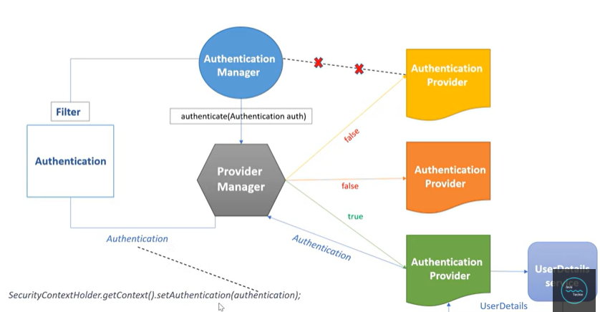

Here are key aspects of the AuthenticationManager in Spring Security:

**1. Interface Definition:**

* The AuthenticationManager interface is defined in the org.springframework.security.authentication package.
* It declares a single method: authenticate(Authentication authentication), which takes an Authentication object representing the user's authentication request and returns an Authentication object representing the authenticated user (if authentication is successful).

**2. Authentication Process:**

* When a user attempts to authenticate (e.g., logs in) to a Spring Security-protected application, the authentication request is routed to the AuthenticationManager.
* The AuthenticationManager delegates the authentication process to one or more configured AuthenticationProvider instances responsible for authenticating users using different mechanisms (e.g., database authentication, LDAP authentication, custom authentication logic).
* Each AuthenticationProvider attempts to authenticate the user based on the provided credentials and returns an Authentication object representing the authenticated user or throws an AuthenticationException if authentication fails.

**3. Configuring Authentication Providers:**

* In a Spring Security configuration class (annotated with @Configuration and @EnableWebSecurity or @EnableGlobalMethodSecurity), you can configure and customize the AuthenticationManager by providing one or more AuthenticationProvider implementations.
* Common implementations of AuthenticationProvider include DaoAuthenticationProvider (for database-based authentication), LdapAuthenticationProvider (for LDAP authentication), JwtAuthenticationProvider (for JWT-based authentication), and custom AuthenticationProvider implementations.

**Que: Explain ProviderManager in Spring security?**

**Ans:** In Spring Security, the ProviderManager is a key component responsible for managing authentication providers and orchestrating the authentication process within the security framework. It acts as a central authentication manager that delegates authentication requests to a chain of authentication providers for authentication and authorization.

The ProviderManager is a specific implementation of the AuthenticationManager interface in Spring Security that manages a chain of authentication providers.

Here's an explanation of the ProviderManager and its role within Spring Security:

**1. Authentication Providers:**

* Spring Security supports multiple authentication mechanisms through authentication providers, such as DaoAuthenticationProvider, LdapAuthenticationProvider, JwtAuthenticationProvider, OAuth2AuthenticationProvider, and custom authentication providers.

**2. Authentication Process:**

* When a user attempts to authenticate (e.g., login) to a Spring Security-protected application, the authentication request is sent to the ProviderManager.
* The ProviderManager iterates through its configured list of authentication providers in sequence until a provider successfully authenticates the user or all providers are exhausted.
* Each authentication provider checks if it supports the authentication request (based on the authentication type or provider-specific criteria) and attempts authentication if supported.
* If authentication is successful, the authentication provider returns an Authentication object representing the authenticated user with granted authorities (roles).

**3. Provider Chain:**

* The ProviderManager maintains a provider chain, which is an ordered list of authentication providers.
* The order of authentication providers in the provider chain determines the sequence in which authentication providers are consulted during the authentication process.

**4. Exception Handling:**

* The ProviderManager handles authentication failures and exceptions thrown by authentication providers during the authentication process.
* It manages authentication exceptions, such as BadCredentialsException, DisabledException, LockedException, and custom exceptions, by propagating them to the authentication flow for appropriate handling and response generation.

**Que: What are the Spring security tools you have used in your project?**

**Ans:** Spring Security is a powerful framework that provides comprehensive security features for Java applications, especially those built using the Spring Framework. It offers various tools and components to implement authentication, authorization, and other security-related functionalities effectively.

Some of the external tools and libraries often used with Spring Security:

**1. OAuth 2.0 Providers (e.g., Okta, Keycloak, Auth0):**

These are identity providers that implement the OAuth 2.0 protocol for authentication and authorization.

Spring Security can integrate with OAuth 2.0 providers to enable Single Sign-On (SSO) and secure access to resources.

**2. JSON Web Tokens (JWT):**

JWT is a compact, URL-safe token format that can be used for securely transmitting information between parties. Spring Security can be configured to use JWT for authentication and authorization, especially in stateless applications.

**3. Spring Session:**

Spring Session provides extra functionalities for managing HTTP sessions in Spring-based applications.

It can be integrated with Spring Security to manage session-related security aspects more effectively.

**4. Spring Boot Actuator:**

Spring Boot Actuator provides monitoring and management capabilities for Spring Boot applications.

It includes security-related endpoints that can be secured using Spring Security to monitor and manage application security configurations.

**5. OpenID Connect (OIDC) Providers:**

OIDC providers offer authentication and Single Sign-On services based on the OpenID Connect protocol.

Spring Security can integrate with OIDC providers to enable secure authentication and access control in web applications.

**Que: What is JWT? How does it works?**

**Ans:** JWT stands for JSON Web Token. It is a compact, URL-safe token format that is used for securely transmitting information between parties as a JSON object. JWTs are commonly used for authentication and authorization in web applications, APIs, and microservices architectures. They are self-contained and can contain information about the user or the application's state.

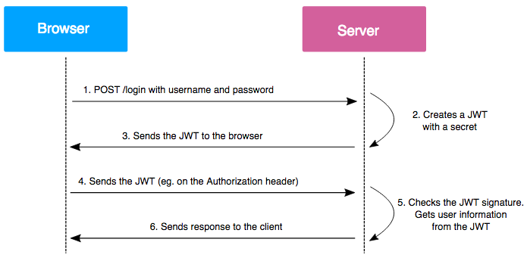

Here's how JWT works:

**1. Token Structure: JWTs consist of three parts separated by dots (.):**

**Header:** Contains metadata about the token such as the type of token (JWT) and the signing algorithm used.

**Payload:** Contains the claims or attributes about the user or the application's state. These claims are typically in JSON format and can include information like user ID, roles, expiration time, etc.

**Signature:** Used to verify that the token was not tampered with during transmission. It is created by combining the header, payload, and a secret key using a specified algorithm (e.g., HMAC with SHA-256).

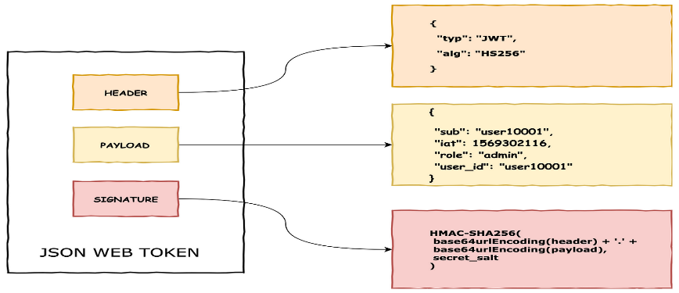

**2. Token Generation (Authentication):** When a user logs in or authenticates with the server, the server generates a JWT and sends it back to the client as part of the authentication response. The JWT typically contains information about the user (e.g., user ID, roles) and is signed by the server using a secret key.

**3. Token Verification (Authorization):** When the client makes subsequent requests to access protected resources or endpoints, it includes the JWT in the request headers (commonly in the Authorization header as a Bearer token). The server verifies the JWT's signature using the secret key it shares with the client. If the signature is valid, the server extracts the claims from the payload to authorize the request (e.g., checking user roles, permissions).

**4. Stateless Authentication:** JWTs are stateless, meaning the server does not need to store session data or maintain user sessions. This makes JWTs suitable for scalable and distributed architectures, as each request can be independently authenticated using the JWT's information.

**5. Expiration and Refresh:** JWTs can include an expiration time (exp claim) to limit their validity period. Clients can request new JWTs or refresh tokens from the server when the current token expires without needing to reauthenticate.

**6. Cross-Origin Resource Sharing (CORS):** JWTs can be securely transmitted across different domains or origins using HTTP headers like Access-Control-Allow-Origin and Access-Control-Allow-Headers to enable cross-origin resource sharing.

**Que: Explain AbstractSecurityInterceptor in spring security?**

**Ans:**

* The AbstractSecurityInterceptor is a fundamental component in Spring Security that plays a critical role in the security architecture of Spring applications. It is an abstract class that serves as the base for various security interceptors used to enforce security policies, perform access control checks, and intercept requests within a Spring Security-enabled application.
* The AbstractSecurityInterceptor intercepts and protects secure objects within the application, such as HTTP requests, method invocations, or service operations that require security checks.
* In Spring Security, the AbstractSecurityInterceptor handles the initial authorization of incoming requests. AbstractSecurityInterceptor has two concrete implementations:
* **FilterSecurityInterceptor**: It will authorize all authenticated user requests.
* **MethodSecurityInterceptor**: This is crucial for implementing method-level security. It allows us to secure our program at the method level.

**Que: What is the intercept-url pattern and why do we need it?**

**Ans:** The intercept-url pattern allows developers to define access control rules for URLs, specifying which URLs require authentication, authorization, or are accessible without authentication (public URLs).

* The intercept-url pattern supports various security constraints and attributes, such as
* permitAll (allow access to all users),
* authenticated (require authentication),
* hasRole (require specific roles),
* hasAuthority (require specific authorities),
* hasIpAddress (allow based on IP address),
* hasAnyRole (require any of the specified roles),
* custom security expressions.

**Ordering and Precedence:**

* The order of intercept-url patterns in the security configuration is significant, as it determines the precedence and matching order of access control rules.
* Patterns are evaluated sequentially, and the first matching pattern defines the access control rule applied to the request.

**Que: Does order matter in the intercept-url pattern? If yes, then in which order should we write it?\**

**Ans:** Yes, ordering is crucial when we have multiple intercept-URL patterns. Multiple intercept URLs should be written from more specific to less specific. As intercept-URL patterns are processed in the order they appear in a spring security configuration file, the URL must match the right pattern.

**Que: What are Caching Technique?**

**Ans:** Caching is a technique used in computer science and software engineering to improve the performance and efficiency of systems by temporarily storing frequently accessed or computed data. The primary purpose of caching is to reduce the time and resources required to retrieve or compute data by storing it in a faster and more accessible location. Caching can be applied at various levels within a system, including hardware, software, and network components.

Here are some key concepts and aspects of caching:

**Cache:**

A cache is a hardware or software component that stores data temporarily for quick access. It acts as a high-speed buffer between slower storage or computation systems and the components that need the data. Caches are designed to provide fast read/write operations and reduce latency in data retrieval.

**Cache Hit and Cache Miss:**

**Cache Hit:** When a requested piece of data is found in the cache, it is called a cache hit. Cache hits result in faster access times because the data is already available in the cache.

**Cache Miss**: When a requested piece of data is not found in the cache and needs to be fetched from the original source (e.g., disk, database, network), it is called a cache miss.

**Types of Caching:**

**In-Memory Caching:** Storing data in the main memory (RAM) of a computer for fast access. In-memory caching is commonly used in applications to cache frequently accessed data, such as database query results, API responses, or computed values.

**Web Caching:** Storing web content (e.g., HTML pages, images, scripts) temporarily on proxy servers or client devices to reduce load times and bandwidth usage. Web caching improves the performance of websites and web applications by serving cached content to users instead of fetching it from origin servers.

**Database Caching:** Caching database query results or frequently accessed data in memory to avoid repeated database accesses. Database caching improves query performance and reduces database load.

**Content Delivery Network (CDN) Caching:** Distributing cached content across geographically distributed servers (CDN nodes) to deliver web content closer to end-users. CDN caching reduces latency and improves content delivery speed for global audiences.

**Que: What do you mean by HASHING in spring security?**

**Ans:** In Spring Security, hashing refers to the process of converting sensitive information, such as passwords, into a hashed representation using cryptographic hash functions.

Hashing is a crucial security measure used to protect sensitive data by converting it into a non-reversible, fixed-length string of characters (the hash value) that is computationally difficult to reverse engineer or decipher.

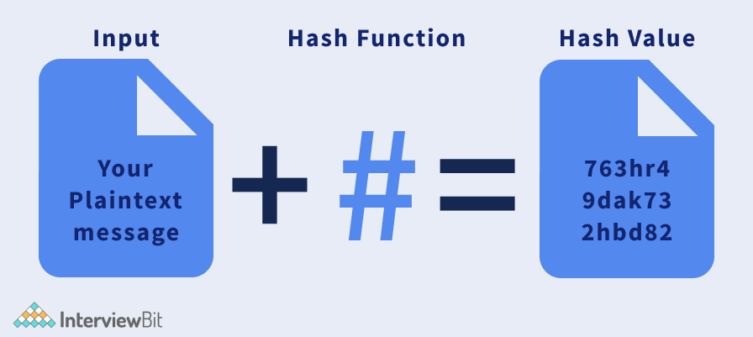

**Password Hashing:**

* One of the primary use cases of hashing in Spring Security is hashing user passwords before storing them in a database or authentication provider.
* When a user registers or updates their password, Spring Security hashes the plaintext password using a cryptographic hash function (e.g., bcrypt, SHA-256) and stores the hashed password in the database.
* Hashing ensures that even if the database is compromised, attackers cannot directly retrieve the original passwords as they only have access to the hashed representations.
* Spring Security uses secure cryptographic hash functions such as bcrypt, PBKDF2, SHA-256, and SHA-512 for password hashing.
* To enhance security and mitigate common attacks like rainbow table attacks, Spring Security uses salted hashes for password storage.

**Que: Explain salting and its usage.**

**Ans**: Salting is a technique used in cryptography and security to enhance the security of hashed data, particularly passwords. It involves adding a random and unique value (known as a salt) to the plaintext data before hashing it.

* A salt is a random value added to the plaintext password before hashing, ensuring that even if two users have the same password, their hashed passwords will be different due to the unique salts.
* Common methods for generating salts include using random number generators or cryptographic secure random functions.
* After adding the salt to the plaintext data, the combined value (salted password) is then hashed using a cryptographic hash function, such as bcrypt, PBKDF2, SHA-256, or SHA-512.

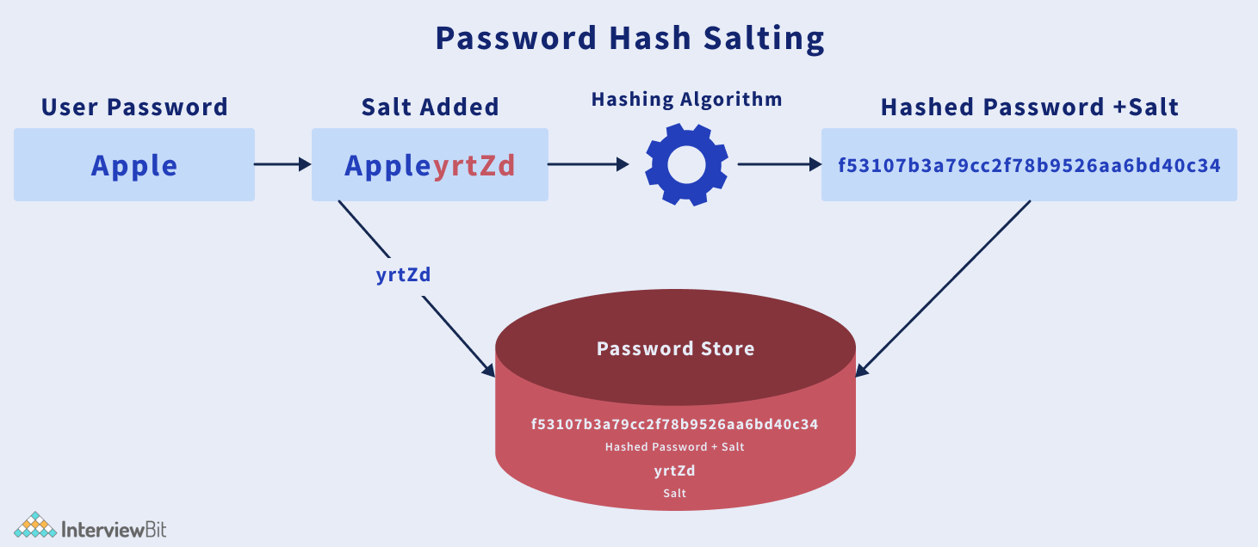

**Que: What is PasswordEncoder?**

**Ans:** PasswordEncoder is an interface provided by Spring Security that defines a contract for encoding (hashing) and verifying passwords. It is a fundamental component used for securely handling passwords in Spring Security-enabled applications. The PasswordEncoder interface abstracts the process of password hashing, salting, and verification, allowing developers to implement various encoding strategies and hash functions based on their security requirements.

Here are key aspects of the PasswordEncoder interface:

1. Encoding Password

2. Salting

3. Hashing Algorithms

4. Verification of Passwords

This interface defines two methods:

**1. encode(rawPassword):**

* This method takes a raw (plaintext) password as input and returns the hashed and salted representation of the password.
* It internally generates a random salt, appends it to the raw password, and then hashes the combined value using the chosen hashing algorithm (in this case, BCrypt).

**2. matches(rawPassword, encodedPassword):**

* This method compares a raw (plaintext) password with a previously encoded password to check if they match.
* It takes the raw password and the encoded (hashed) password as inputs and performs a verification by hashing the raw password and comparing the hashed value with the encoded password.

**BCryptPasswordEncoder**:

* Another widely used implementation in Spring Security is the BCryptPasswordEncoder, which uses the bcrypt hashing algorithm with built-in salt generation and management.
* Bcrypt automatically generates and manages salts internally, simplifying the salting process for developers.

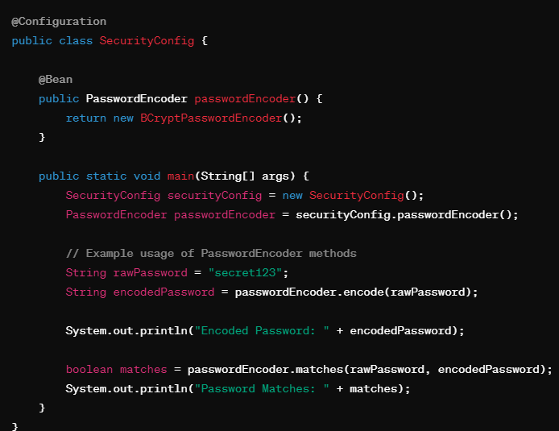

**Que: Explain spring security OAuth2?**

**Ans**: OAuth2 is an authorization framework that enables secure delegated access to resources on behalf of a resource owner (user) by allowing clients (applications) to obtain access tokens from an authorization server. In the context of Spring Security, Spring Security OAuth2 provides support for implementing OAuth2-based authentication and authorization mechanisms in Spring applications.

OAuth 2.0, permits client applications to access protected resources via an authorization server.

Here's an overview of Spring Security OAuth2 and its key components:

**OAuth 2.0 Roles:**

* **Resource** **Owner**: The user who owns the protected resources and grants access to client applications.
* **Client**: The application requesting access to the protected resources on behalf of the resource owner.
* **Authorization** **Server**: Manages the authorization and token issuance process, validates client credentials, and issues access tokens.
* **Resource** **Server**: Hosts the protected resources and validates access tokens to grant or deny access to clients.

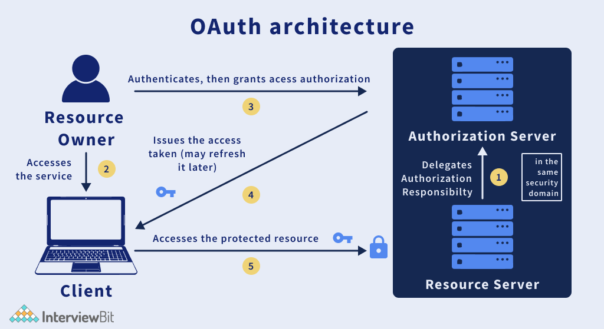

Below is an overview of how Spring Security OAuth2 typically works:

**1. Client Registration:**

* Clients (applications) register themselves with the Authorization Server by providing details such as client ID, client secret, redirect URIs, allowed grant types, and scopes.

**2. Authorization Request:**

* When a client needs access to a protected resource on behalf of a user, it initiates an authorization request by redirecting the user's browser to the Authorization Server's authorization endpoint.

**3. User Authentication and Authorization**:

* The Authorization Server authenticates the user (resource owner) by prompting them to log in and authorize the client's access request.
* Depending on the grant type, the user may be prompted to grant permissions (scopes) to the client for accessing specific resources.

**4. Authorization Code Grant Flow:**

* In the Authorization Code Grant flow (used for server-side applications), the Authorization Server redirects the user's browser back to the client's redirect URI with an authorization code.
* The client exchanges this authorization code for an access token and possibly a refresh token by making a secure backend call to the Authorization Server's token endpoint.

**5. Access Token and Refresh Token:**

* (access token mil jayega usi se user ke behalf par access krega aur jab token expire ho jayega toh wo naya token bhi issue krwa lega)
* The Authorization Server issues an access token to the client, representing the user's authorization to access specific resources for a limited duration.
* Optionally, the server may also issue a refresh token that the client can use to obtain new access tokens without user interaction when the access token expires.

**6. Resource Access:**

* With the access token, the client includes it in requests to the Resource Server (API server) to access protected resources.

**7. Token Expiry and Refresh:**

* Access tokens have a limited validity period (expires in minutes or hours) to mitigate security risks. When an access token expires, the client can use the refresh token (if provided) to obtain a new access token without user involvement.
* The client makes a refresh token request to the Authorization Server's token endpoint, exchanging the refresh token for a new access token and possibly a new refresh token.

**8. Token Revocation and Management:**

* Spring Security OAuth2 supports token revocation mechanisms, allowing clients or users to revoke access tokens and refresh tokens when necessary.
* Token management includes storing tokens securely, handling token expiration, revocation, and providing mechanisms for token validation and introspection.

**Oauth 2.0 Grants:(kya kya grant de raha hai user)**

* **Authorization Code Grant:** Used for web applications where the client redirects the user to the authorization server for authentication and authorization. After approval, the authorization server issues an authorization code that the client exchanges for an access token.
* **Implicit Grant:** Used for browser-based applications (single-page apps) where the access token is obtained directly via a redirection response from the authorization server.
* **Client Credentials Grant**: Used for server-to-server communication where the client (application) directly requests an access token from the authorization server using its credentials.
* **Resource Owner Password Credentials Grant**: Allows the client to exchange the resource owner's username and password for an access token, suitable for trusted clients.

**Que: What do you mean by OAuth2 Authorization code grant type?**

**Ans:** The OAuth 2.0 Authorization Code Grant Type is one of the grant types defined by the OAuth 2.0 specification for obtaining access tokens, which are used to access protected resources on behalf of a user. It is commonly used in scenarios where the client application can securely handle the user's credentials and is typically used for server-side web applications or mobile apps. Used for web applications where the client redirects the user to the authorization server for authentication and authorization. After approval, the authorization server issues an authorization code that the client exchanges for an access token.

**Que: What is CORS?**

**Ans:** CORS referring to "Cross-Origin Resource Sharing" (CORS), which is a security feature implemented by web browsers to control how web pages from one domain can interact with resources (e.g., APIs, fonts, scripts) from another domain. CORS is important for preventing malicious attacks and ensuring secure communication between web applications across different origins.

**Same-Origin Policy:**

* Web browsers enforce a security policy called the Same-Origin Policy, which restricts JavaScript code from making requests to resources on a different domain, port, or protocol (origin) than the one that served the web page.
* This policy helps mitigate various security risks, such as cross-site scripting (XSS) attacks and data leakage between domains.

Example:

Let's say you have two web applications:

***Application A: https://app-a.example.com***

***Application B: https://app-b.example.com***

* The Same-Origin Policy will prevent JavaScript code running in a page served from Application A (https://app-a.example.com) from accessing resources or making requests to Application B (https://app-b.example.com) due to the difference in origins.

**Cross-Origin Resource Sharing (CORS):**

* CORS is a mechanism that relaxes the Same-Origin Policy by allowing servers to specify which domains are allowed to access their resources.
* When a web page makes a cross-origin HTTP request (e.g., XMLHttpRequest, Fetch API) to a different domain, the browser sends a preflight request to the server to check if the actual request is allowed based on CORS headers.

Let's explain Cross-Origin Resource Sharing (CORS) with an example involving two web applications: a frontend application (Client) hosted on one domain and a backend API (Server) hosted on another domain. This scenario illustrates how CORS allows the frontend to make cross-origin requests to the backend API securely.

**Frontend Application (Client):**

***Domain: https://client.example.com***

**Backend API (Server):**

***Domain: https://api.example.com***

***Endpoint: https://api.example.com/data***

**Request without CORS:**

* If the server at https://api.example.com does not implement CORS, when the client code tries to fetch data from the API endpoint (https://api.example.com/data), the browser blocks the request due to the Same-Origin Policy (SOP) since the origins are different (https://client.example.com vs. https://api.example.com).
* You'll see an error in the browser console like: "Access to fetch at 'https://api.example.com/data' from origin 'https://client.example.com' has been blocked by CORS policy."



**Implementing CORS:**

* To allow cross-origin requests from https://client.example.com, the backend API server at https://api.example.com/data needs to send CORS headers in its HTTP responses.
* The server responds with the following CORS headers in the HTTP response:

**Configure CORS Globally:**

* In a Spring Boot application, you can configure CORS globally by adding a @CrossOrigin annotation to your main configuration class or by using the WebMvcConfigurer interface.

